K. J. Somaiya College of Engineering, Mumbai-77
(Autonomous College Affiliated to University of Mumbai)

End Semester Exam
April - May 2016
Max. Marks: 100 Duration: 03 hrs
Class: B E Semester: VIII
Name of the Course: Machine learning Branch: Computer
Course Code:
Instructions:
- All Questions are Compulsory
- Draw neat diagrams
- Assume suitable data if necessary

Question No. |  | Max. Marks
Q 1 (a) | Define machine learning. Mention the reasons for choosing a machine learning algorithm for an application. List possible functions, mathematical or theoretical models that can be used for implementing a machine learning algorithm.  Definition: 02  Reasons for ML:04  List of functions: 04 | 10  CO:1
Q 1 (b) | Consider the following set of points: {(-2 , -1) , (1 , 1) , (3 , 2)} Find the least square regression line for the given data points.  What are the limitations of linear regression?  Ans:  - Let us organize the data in a table.  X y x y x ²  - -2 -1 2 4  - 1 1 1 1  - 3 2 6 9  - Σx = 2 Σy = 2 Σxy = 9 Σx² = 14  We use formula to calculate a and b as follows  a = (nΣx y - ΣxΣy) / (nΣx² - (Σx)²) = (3*9 - 2*2) / (3*14 - 2²) = 23/38  b = (1/n)(Σy - a Σx) = (1/3)(2 - (23/38)*2) = 5/19  Problem solved with correct answer and formula written: 06  Limitations of Linear Regression:04 | 10  CO:1
Q2 (a) | Which feature will be at the root node of the decision tree trained for the following data? Solve by calculating information gain.  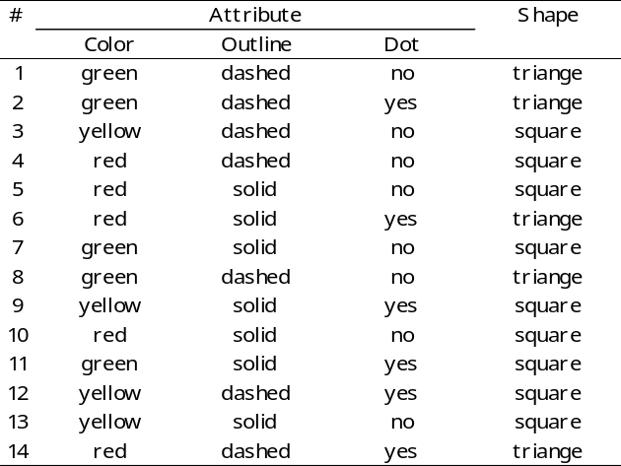  OR  Which feature will be at the root node of the decision tree trained for the above data? Solve by calculating Gini Index.  Answer: Root : Color  Steps in construction of decision by information gain / gini index: 04  calculation of info gain / gini of each attribute: 04  final choice of node at the root of decision tree: 02 | 10  CO:2,3  10
Q2 (b) | What is clustering? Explain Hierarchical and K-means clustering approach.  Explanation of clustering as unsupervised learning technique: 02  Heirachical: 04  k-means: 04 | 10  CO:2,3
Q3 (a) | Explain the step by step process of finding maximum margin linear separators in support vector machines.  explain SVM : 03  derivations: 05  formula:02  OR  What is quadratic programming solution to finding maximum margin separators in support vector machines?  How Kernel functions are useful in nonlinear classification in SVM?  explain SVM: 03  quadratic prg soln: 05  Kernel functions: 02 | 10  10  CO:2,3
Q3 (b) | Following is the Markov Model created for weather prediction tomorrow on the basis of weather today.  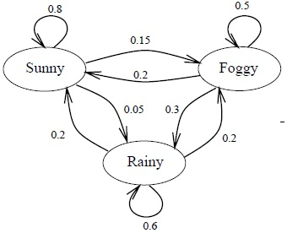  Assuming, you are locked in a room and are supposed to predict for the weather outside. The only evidence is through a caretaker person who visits your room with an umbrella or not.  The probability of seeing an umbrella based on weather outside is given by  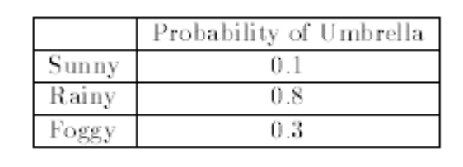  - Suppose the day you were locked in it was sunny. The next day the caretaker carried an umbrella into the room. Assuming that the prior probability of the caretaker carrying an umbrella on any day is 0.5. What is the probability that the second day was rainy?  - Suppose the day you were locked in it was sunny. The caretaker brought in umbrella on day 2, but not on day 3. Assuming that the prior probability of the caretaker carrying an umbrella on any day is 0.5. What’s probability that it’s foggy on day 3?  Answers:  a)  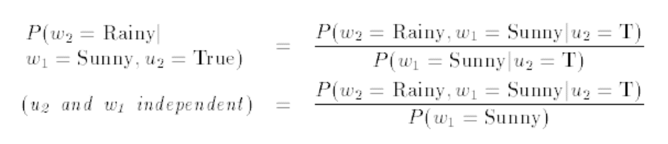  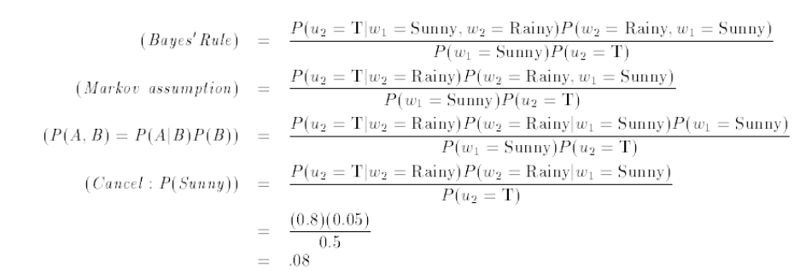  b)  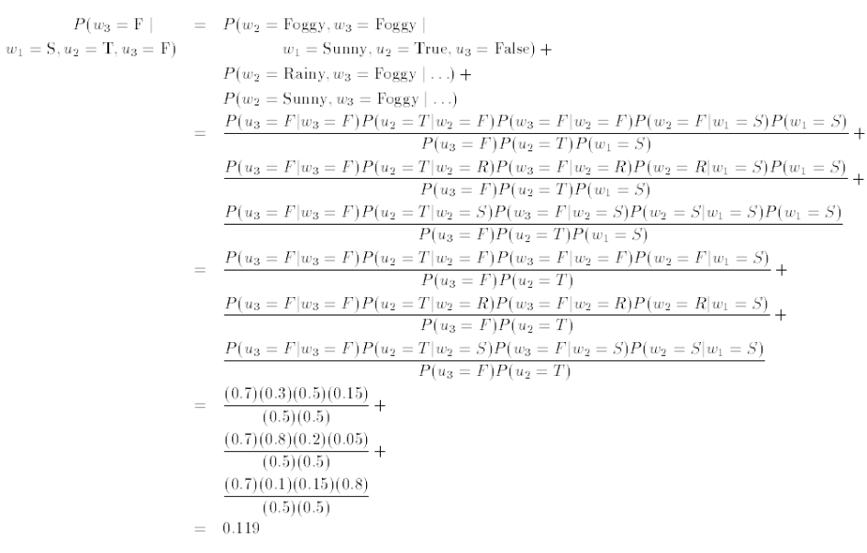 | 05  05
Q4 (a) | Following Bayesian Network is designed. Answer the following for this network.  - What is the probability that the alarm has sounded but neither a burglary nor an earthquake has occurred, and both Ali and Veli call?  - What is the probability that there is a burglary given that Ali calls?  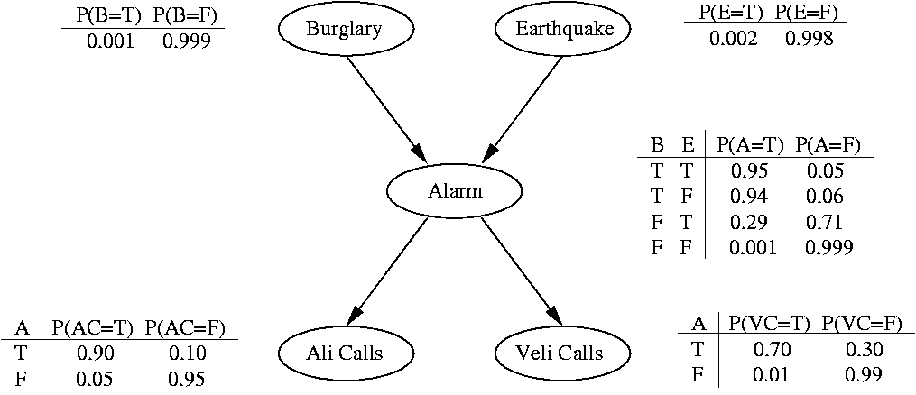  - 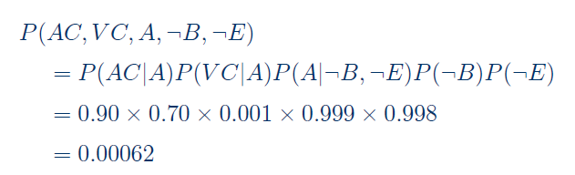  - 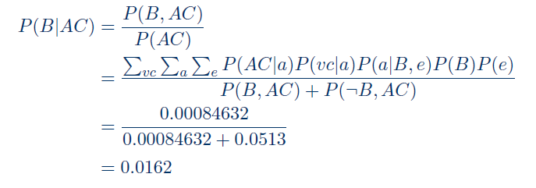 | 05  05
Q4 (b) | Explain backpropagation algorithm for Neural Networks in detail.  neural net: 02  algo: 06  proper steps:02  OR  Differentiate between supervised, unsupervised learning methods with an example of each.  supervised: 04  unsupervised:04  example:02 | 10  CO:2,3  10
Q5 | Write detailed explanation of any TWO of the following with appropriate example.  - Principal Component Analysis  - Independent Component Analysis  - Reinforcement Learning  - Model based Learning  - Supervised learning after clustering  explanation of topic:02  approach w r t machine learning:04  example/application:02 | 20  CO:4,5

